Práctica 10. Archivos y Tema Hijo
Hector Cevallos Paredes
Alejandro Priego Izquierdo
1. De tu última práctica, entra en la carpeta de tu tema y localiza los siguientes archivos:
Header.php

function get_header( $name = null, $args = array() ) {
/**
* Fires before the header template file is loaded.
*
* @since 2.1.0
* @since 2.8.0 The `$name` parameter was added.
* @since 5.5.0 The `$args` parameter was added.
*
* @param string|null $name Name of the specific header file to use. Null for the default header.
* @param array $args Additional arguments passed to the header template.
*/
do_action( 'get_header', $name, $args );

$templates = array();
$name = (string) $name;
if ( '' !== $name ) {
$templates[] = "header-{$name}.php";
}

$templates[] = 'header.php';

if ( ! locate_template( $templates, true, true, $args ) ) {
return false;
}
}

Footer.php

function get_footer( $name = null, $args = array() ) {
/**
* Fires before the footer template file is loaded.
*
* @since 2.1.0
* @since 2.8.0 The `$name` parameter was added.
* @since 5.5.0 The `$args` parameter was added.
*
* @param string|null $name Name of the specific footer file to use. Null for the default footer.
* @param array $args Additional arguments passed to the footer template.
*/
do_action( 'get_footer', $name, $args );

$templates = array();
$name = (string) $name;
if ( '' !== $name ) {
$templates[] = "footer-{$name}.php";
}

$templates[] = 'footer.php';

if ( ! locate_template( $templates, true, true, $args ) ) {
return false;
}
}
2. Creando tema hijo:
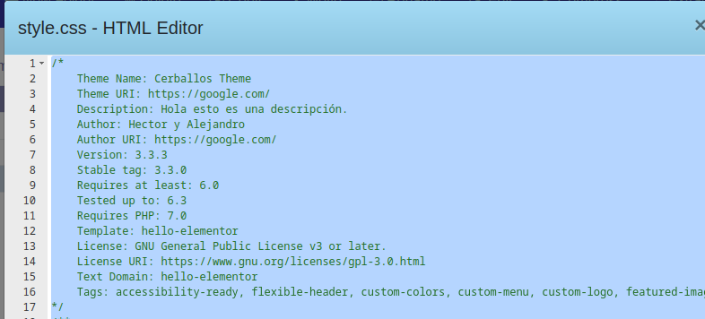
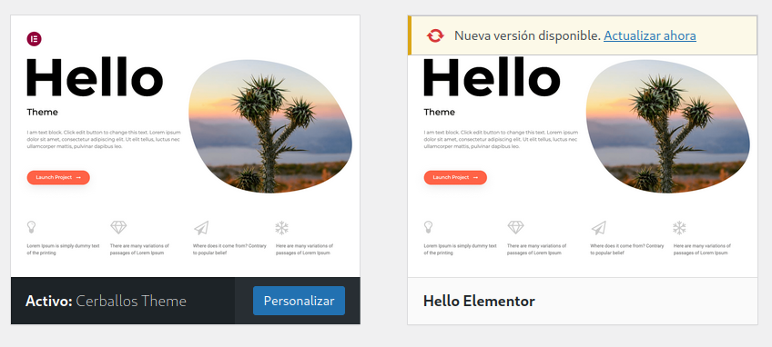
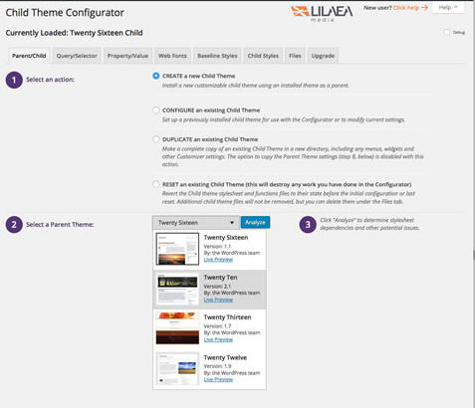

3. Realiza estos cambios de estilo:
Original:

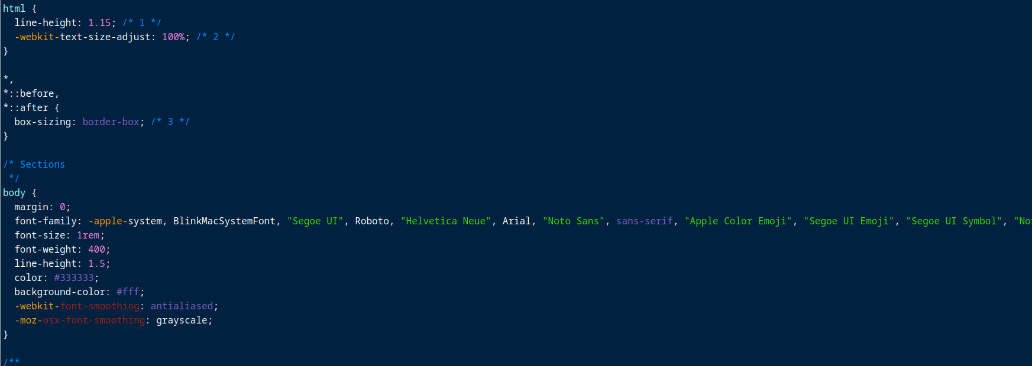
Modificado:

